**Owlisdom Portal Issues: 14 – 05 – 25, 15-05**

# Functionality Issues:

## Func_01

**Steps to Reproduce:**

**Sign up with an already registered email.**

1. Steps to Reproduce:
   1. Sign in as google.
   2. Log out of portal.
   3. Navigate to the Sign up page.
   4. Sign up with the same email as previously used.
   5. **Notice that, it redirects to a success page.**
   6. Although the user do not receive any email for this signup verification.

## Func_02

**Order chat window in left panel do not appear even when the user starts an order chat.**

**Steps to Reproduce:**

1. Steps to Reproduce:
   1. Place and order.
   2. Navigate to order details.
   3. Update order details such as citation, source etc.
   4. The Order Chat window should appear by now but it is not there.

**Screenshot:**

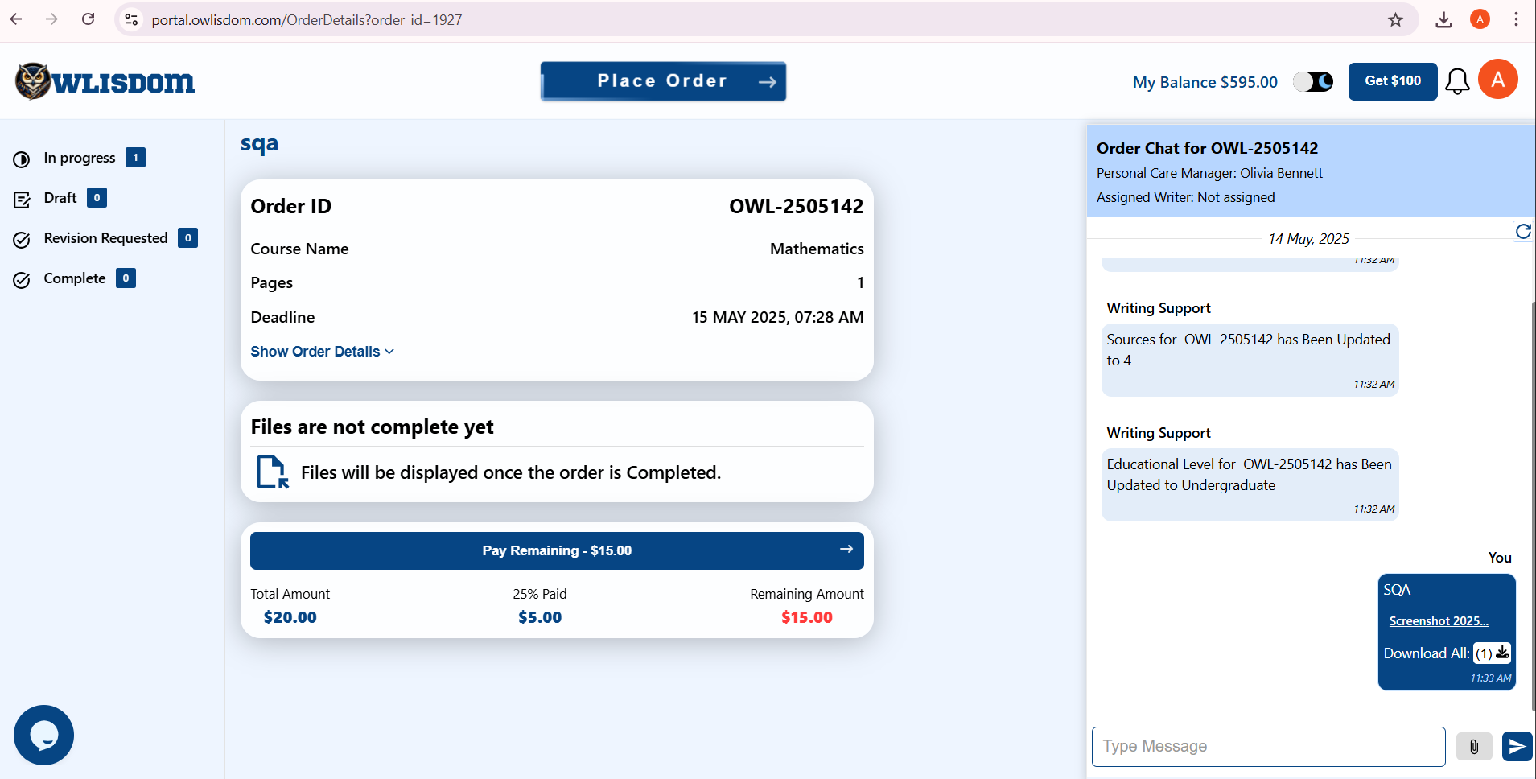

## Func_03

**Sign up success page’s Login button**.

**Steps to Reproduce:**

1. User signs up manually.
2. The sign up button, when clicked, it redirects to success page with message, “Please check your inbox”.
3. On the same page there is Login button.
4. **This login button redirects to sign up page.**

# UI / UX:

## UI_01

**Steps to Reproduce:**

1. Click “forgot Password”.
2. A password email is sent to user. In this email click “Reset Password” button.
3. This button redirects to “Password Reset” page, where user can enter new password.
4. On this page, there is a message **-** “**We sent a link to** [**nahmad0313@gmail.com**](mailto:nahmad0313@gmail.com)**” -** above the input fields.
5. This message is unnecessary.

**Screenshot:**

